Project Design Phase-II

Data Flow Diagram & User Stories

|  |  |
| --- | --- |
| Date | 06 November 2022 |
| Team ID | PNT2022TMID13150 |
| Project Name | NEWS TRACKER APPLICATION |
| Maximum Marks | 4 Marks |

# Data Flow Diagrams:

A Data Flow Diagram (DFD) is a traditional visual representation of the information flows within a system. A neat and clear DFD can depict the right amount of the system requirement graphically. It shows how data enters and leaves the system, what changes the information, and where data is stored.

(DFD) for news tracker application for login:

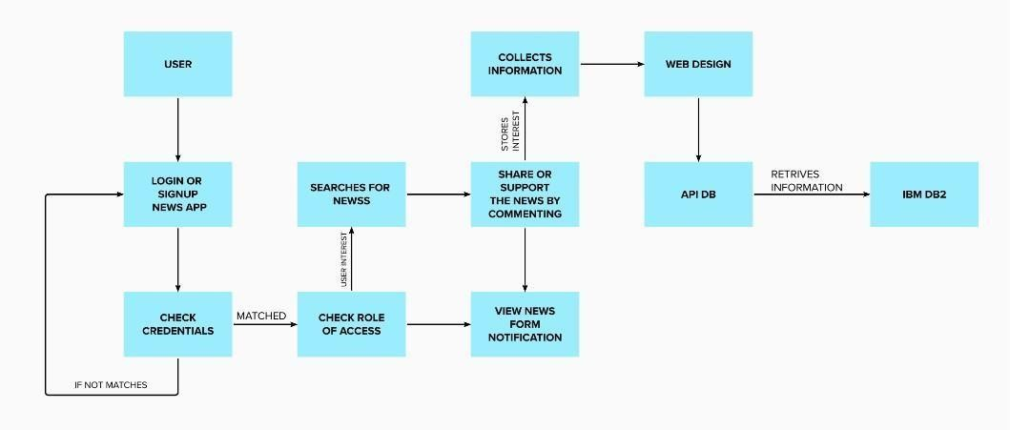

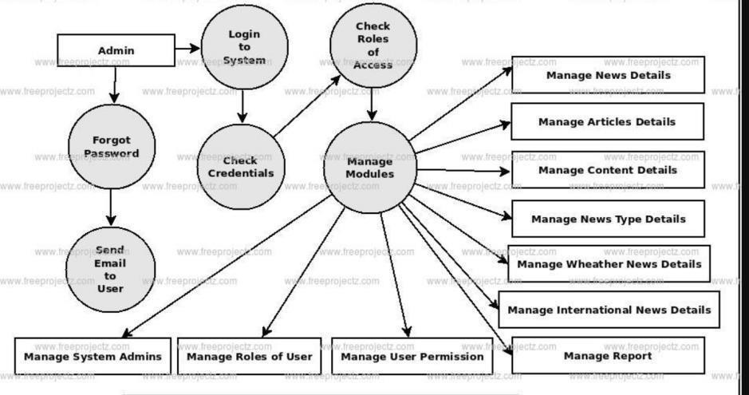

# User Stories :

|  |  |  |  |  |
| --- | --- | --- | --- | --- |
| **User Type** | **Functional**  **Requirement (Epic)** | **User Story Number** | **User Story / Task** | **Acceptance criteria** |
| Customer (Mobile user) | Registration | USN-1 | As a user, I can register for the application by entering my email, password, and confirming my  password. | I can access my account / dashboard |
|  |  | USN-2 | As a user, I will receive confirmation email  once I have registered for the application | I can receive confirmation  email & click confirm |
|  |  | USN-3 | As a user, I can register for the application through Facebook | I can register & access  the dashboard with Facebook Login |
|  |  | USN-4 | As a user, I can register for the application through Gmail | I can receive password to  mail. |
|  | Login | USN-5 | As a user, I can log into the application by entering email & password | I can receive  confirmation mail. |
|  | Dashboard | USN-6 | The news portal and shows the recent  news as Breaking NEWS | I can Open and view the  news portal. |
| Customer (Web user) | Search Bar | USN-7 | User searches for news based on their own interest. | I can view the related news and can watch videos. |
|  |  | USN-8 | The news can be viewed that is appearing on the dashboard. | On the dashboard. I shall click on the news wanted and can  open it. |
| Administrator | Server | USN-9 | Provides correct news available from the database. | Provide the correct news from the database and fake news will be  rejected |
|  |  | USN-10 | Provide live news with video and  audio contents. | I can get the news in  which I am interested. |

2